Final Project Documentation for Web publishing system

**Prepared by:** Mahmoud Mourad Youssef **Date: 8/1/2023**

1. Project description

The Web Publishing System project is a software system designed to assist a local editor of a regional historical society in automating the article review and publishing process. The system will provide tools to maximize the editor's productivity by streamlining the review and publishing process. The system will allow the editor to manage and communicate with a group of reviewers and authors to publish articles to a public website. The system will facilitate communication between authors, reviewers, and the editor via E-Mail. Preformatted reply forms are used in every stage of the articles' progress through the system to provide a uniform review process. The system will also contain a relational database containing a list of Authors, Reviewers, and Articles.

**II.** Project proposal and backup data (request for proposal, statement of work, proposal correspondence, and so on)

The project aims to create a web publishing system that will help the local editor to efficiently manage the process of reviewing and publishing articles on the society's website. Specifically, it will accomplish the following:

* Maximize the editor's productivity by providing tools to automate the article review and publishing process.
* Facilitate communication between authors, reviewers, and the editor via E-Mail.
* Provide a uniform review process using preformatted reply to forms that can be configured via the application's maintenance options.
* Allow the editor to access and manage a relational database containing a list of authors, reviewers, and articles.
* Make the system user-friendly and easy to understand, to minimize the learning curve for the editor.

Preliminary requirements are a set of initial requirements that are defined before the detailed requirements are developed. They are high-level statements of what the project needs to accomplish, and they provide a general understanding of the scope and objectives of the project.

For a web publishing system, some preliminary requirements might include:

* Automation of the review and publishing process: The system should automate the process of managing and communicating with reviewers and authors and allow for the publishing of articles to a public website with minimal manual intervention.
* Editor's productivity: The system should increase the editor's productivity and efficiency, by providing tools to assist in communication and management.
* Easy-to-use and accessible: The system should be easy-to-use and accessible for society members.
* Compliance with regulations: The system should be compliant with data privacy and security regulations, and accessibility guidelines.
* Integration database: The system should be compatible with the existing data structure and database.
* Meeting specific timelines and budget: The system should be designed and developed within a specific timeframe and budget.

**III.** Original and revised contract information and client acceptance documents

**Project Team Members Names and Sign-off:**

|  |  |
| --- | --- |
| **Name** | **Sign-off on Team Contract** |
| **Team Member1** |  |
| **Project manager** |  |

**Code of Conduct:** As a project team, we will accept:

* Professionalism: Team members will conduct themselves in a professional manner and always treat each other with respect and courtesy.
* Communication: Team members will communicate effectively and openly and will work together to resolve any conflicts that may arise.
* Respect for diversity: Team members will respect the diversity of opinions, backgrounds, and experiences of each other and will not discriminate based on race, gender, sexual orientation, religion, or any other protected status.
* Confidentiality: Team members will maintain confidentiality of any sensitive or proprietary information that is shared within the team.
* Compliance with laws and regulations: Team members will comply with all laws and regulations that apply to the project and will report any violations or concerns to the project manager.

**Participation:** We will:

* Responsiveness: Team members are expected to respond to requests for information, feedback, or other inputs in a timely manner.
* Communication: Team members are expected to communicate effectively and regularly with the project manager and other team members, and to keep the project manager informed of any issues or concerns that may impact the project schedule or budget.
* Performance: Team members are expected to perform their assigned tasks and deliverables to the best of their abilities, and to meet the quality standards and deadlines established for the project.
* Cooperation and Collaboration: Team members are expected to work together cooperatively and collaboratively, and to support one another in achieving the project objectives.

**Communication:** We will:

* Frequency: The team will communicate regularly, such as daily or weekly, through team meetings, email, instant messaging, or other agreed-upon methods.
* Responsiveness: Team members will respond to requests for information, feedback, or other inputs in a timely manner, and will keep the project manager informed of any issues or concerns that may impact the project schedule or budget.
* Transparency: Team members will be open and honest about their progress, concerns, and any issues that may arise, and will work together to resolve them.
* Format: Team members will use a standardized format for communications, such as email or instant messaging, and will keep a clear and concise written record of all communications.

**Problem Solving:** We will:

* Identification: Team members will be proactive in identifying potential issues and problems and will report them to the project manager as soon as they arise.
* Assessment: Team members will work together to assess the problem, gather relevant information, and identify potential solutions.
* Resolution: Team members will work together to select and implement the best solution and will communicate the resolution to the project manager and other stakeholders.
* Continuous improvement: Team members will be encouraged to share their observations, experiences, and suggestions for improvement to the problem-solving process.

**Meeting Guidelines:** We will:

* Attendance: Team members are expected to attend all scheduled meetings, including team meetings, project status meetings, and any other meetings deemed necessary by the project manager.
* Responsiveness: Team members are expected to respond to requests for information, feedback, or other inputs in a timely manner.
* Code of conduct: Team members are expected to adhere to the code of conduct outlined in the team contract.
* Problem solving: Team members are expected to follow the problem-solving process outlined in the team contract.

Decision Making: Team members are expected to follow the decision-making process outlined in the team contract.

**IV.** Original and revised project plans and schedules (WBS, Gantt charts and network diagrams, cost estimates, communications management plan, etc.)

1. Planning

1.1 Define project scope and objectives

1.2 Develop project schedule and budget

1.2.1 Develop project plan and deliverables

1.3 Identify stakeholders and conduct stakeholder analysis

1.4 Identify and mitigate risks

1. Implementation

2.1 Develop system requirements

2.1.1 Identify functional and non-functional requirements

2.1.2 Define User Stories and acceptance criteria

2.2 Design user interface

2.2.1 Design wireframes and mockups

2.2.2 Develop user flow diagrams

2.3 Build and test system

2.3.1 Develop system architecture

2.3.2 Test system functionality

2.3.3 Test system performance

2.4 Deployment plan

1. Deployment
   1. Train Users  
      3.1.1 Develop training materials

3.1.2 Conduct training sessions

* 1. Deploy system to production

3.2.1 Perform system migration

3.2.2 Perform system integration

* 1. Monitor and maintain the system

1. Testing
2. Close Out

5.1 Conduct project review and evaluation

5.2 Obtain user acceptance

5.3 Close out project

5.4 Document lessons learned

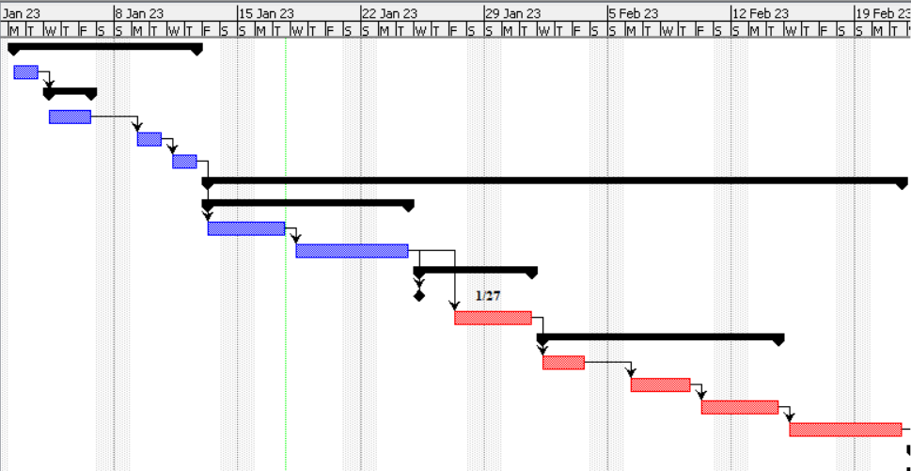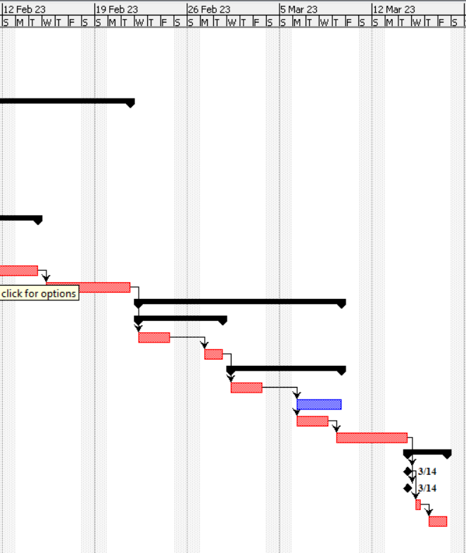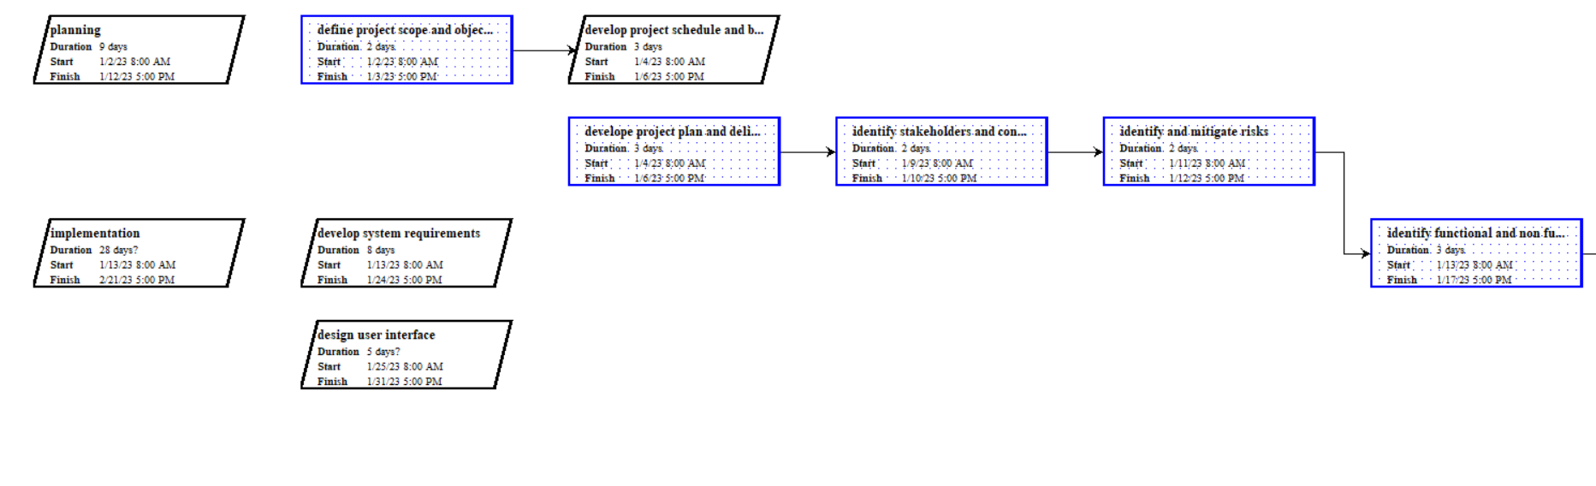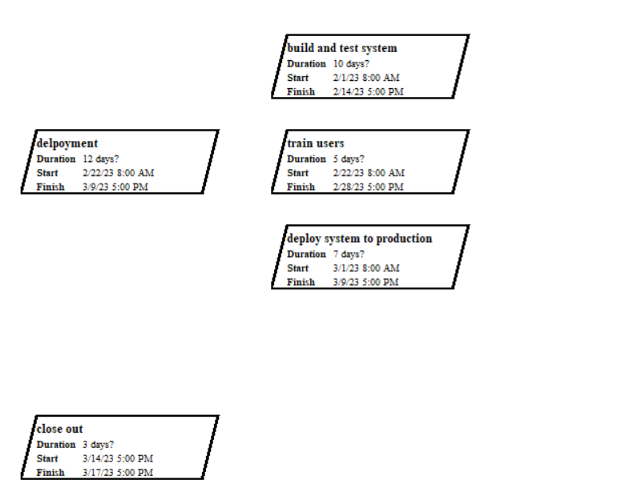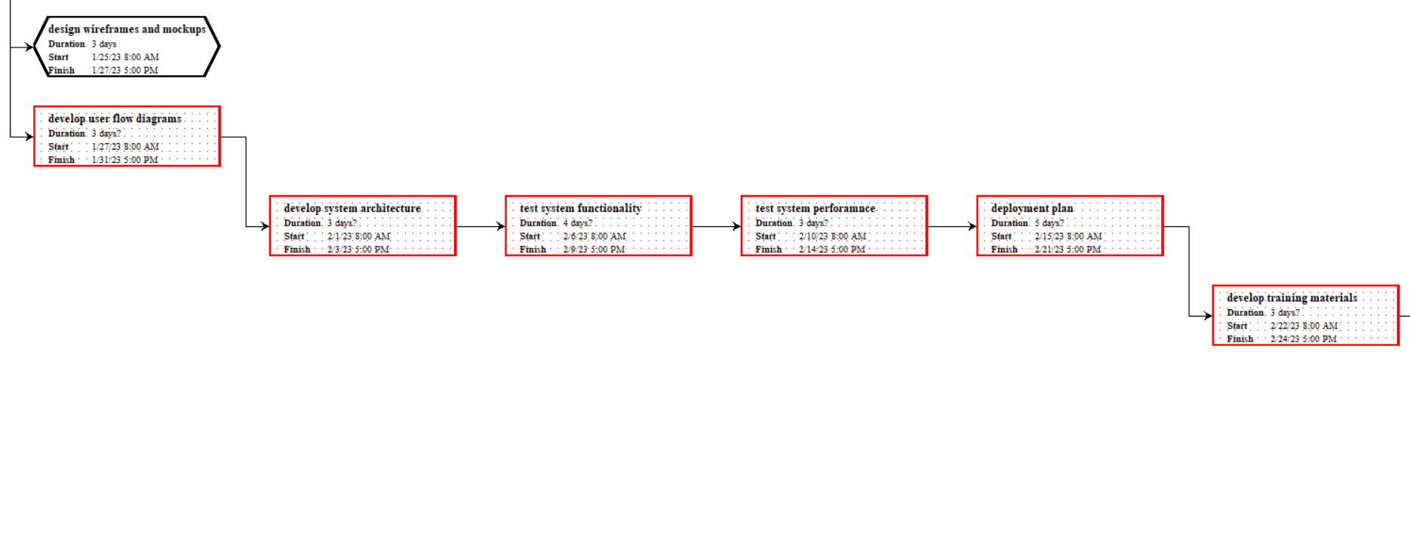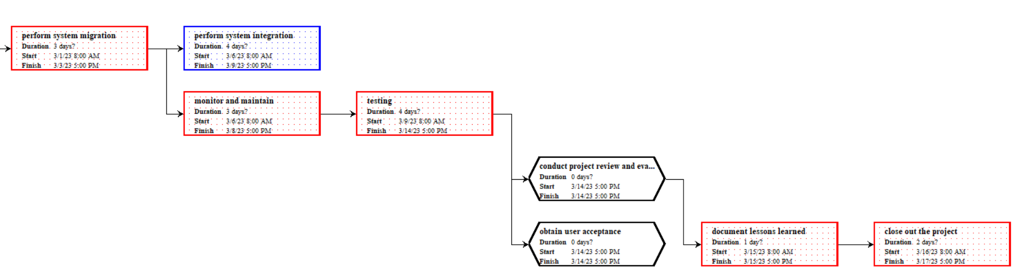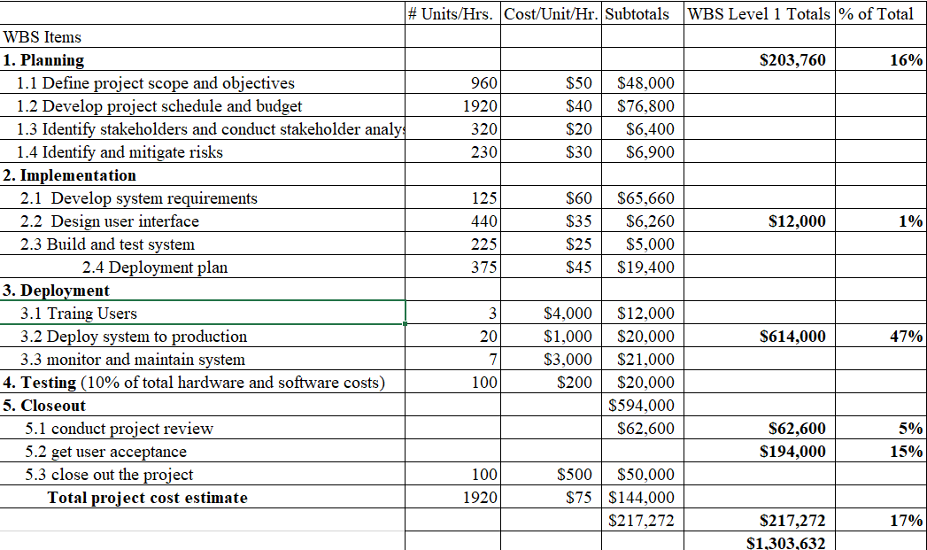

**V.** Design documents

Not applicable.

**VI.** Final project report

Not applicable.

**VII.** Deliverables, as appropriate

|  |  |  |
| --- | --- | --- |
| **Week** | **Task** | **Deliverable** |
| 1-2 | Kickoff meeting and requirements gathering | Project plan and list of deliverables |
| 3-6 | System design and development | System design portfolio |
| 7-8 | System testing and debugging | Testing report |
| 9-10 | User acceptance testing | Feedback report |
| 11-12 | Deployment and training | Deployment and training documentation |
| 13 | Finalize documentation and close project | Final documentation |

**VIII.** Audit reports

Not applicable.

**IX.** Lessons learned reports

|  |
| --- |
| **Prepared by: Mahmoud Mourad Youssef** **Date:12/1/2023**  **Project Name: Web publishing system**  **Project Sponsor:** Dr. Ayman Bahaa  **Project Manager:** Mahmoud Mourad  **Final Budget: 1,304,000** |
| 1. Did the project meet scope, time, and cost goals?   Yes, those criteria were met, the project schedule was met and followed smoothly while not deviating away from the project’s scope, the goals were met while retaining a good quality.   1. What was the success criteria listed in the project scope statement?   Meeting the performance requirements  Meeting the functional requirements  Meeting the user requirements  On-time delivery  On-budget delivery   1. Reflect on whether you met the project success criteria.   Yes, all criteria are met.   1. In terms of managing the project, what were the main lessons your team learned?  * The importance of clear and detailed project scope * The importance of stakeholder engagement * The importance of risk management * The importance of clearly defined success criteria * The importance of communication * The importance of contingency planning  1. Describe one example of what went right on this project.   Effective project scope definition, the project scope statement provided a clear and detailed understanding of the project's objectives, deliverables, and requirements. This helped to ensure that the project stayed on track and delivered the desired outcome. The scope statement also identified the key stakeholders and their roles, which helped to ensure that their needs and concerns were considered throughout the project lifecycle.   1. Describe one example of what went wrong on this project.   Cost overrun risk, the project exceeded the allocated budget due to unforeseen costs or mismanagement of resources, which caused financial constraints and affected the project's continuity.   1. What will you do differently on the next project based on your experience working on this project?   Adequate performance testing, deploying the system, it is important to conduct thorough testing to ensure that the system meets the performance requirements such as response time, scalability, and security. Continual monitoring and controlling, the project team should continuously monitor the project, comparing it to the established budget, and taking corrective action as necessary. |
|  |

**X.** Copies of all status reports, meeting minutes, change notices, and other written and electronic communications

Not applicable.